Test 1:
Run Main Method
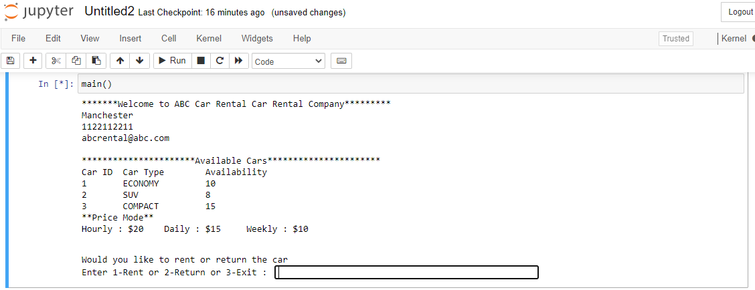

Test 2
Enter 1 to rent
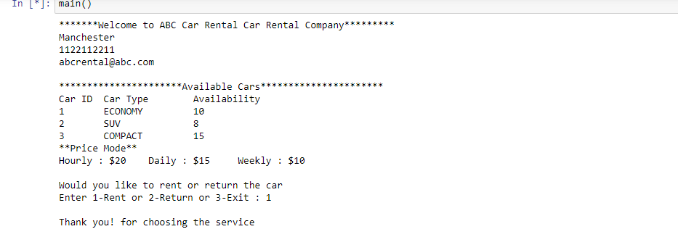
Enter 2 to Return
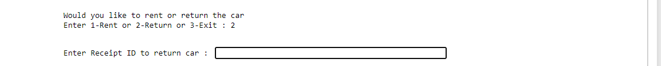

Enter 3 to Exit

Test 2a
Enter ‘oi’ invalid entry:
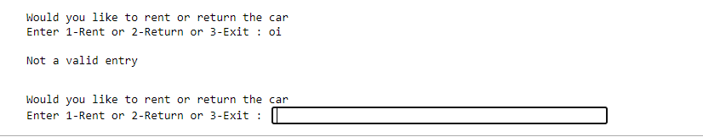

Test 2b
Missed to enter value
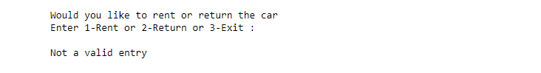
Test 3:
Enter Customer Information
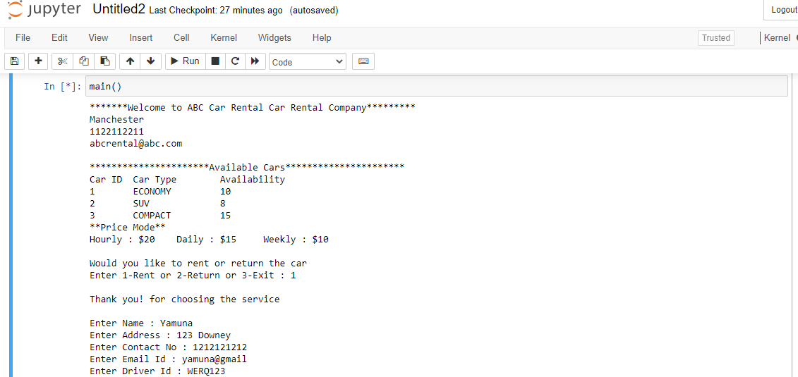
Test 3a
Enter invalid Date and Invalid Time

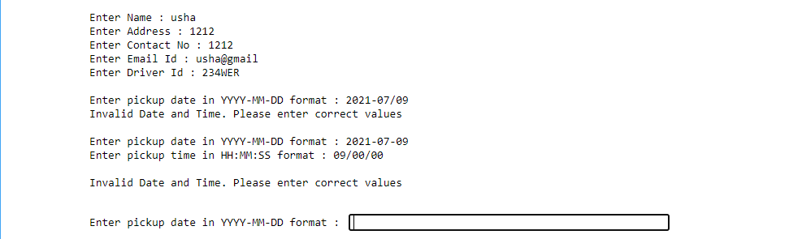

Test 3b
Enter Invalid contact number
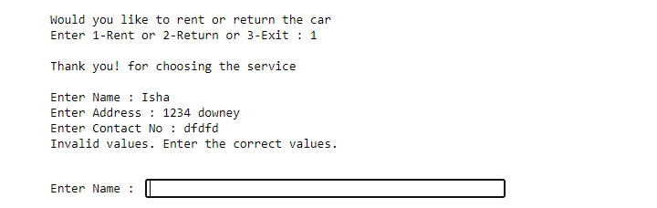

Test 4:
Enter Price Mode, Car ID and No of cars for rent details
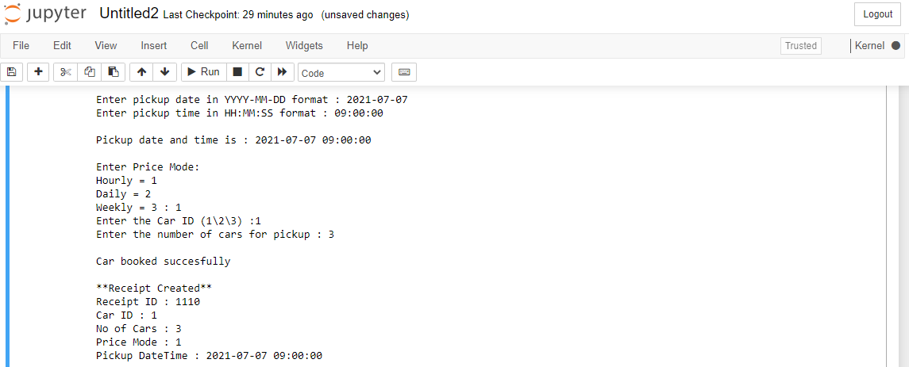
Test 4a
Invalid Price Mode
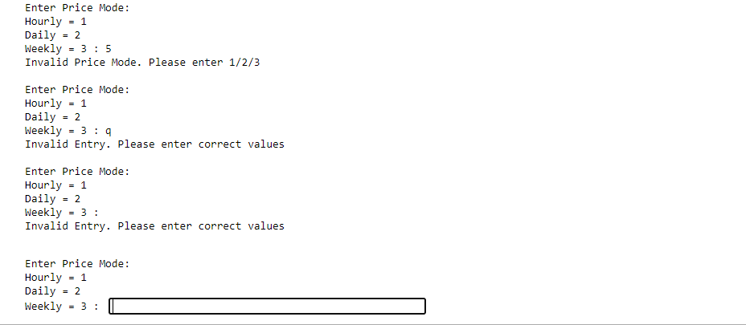

Test 4b
Enter Invalid Car ID
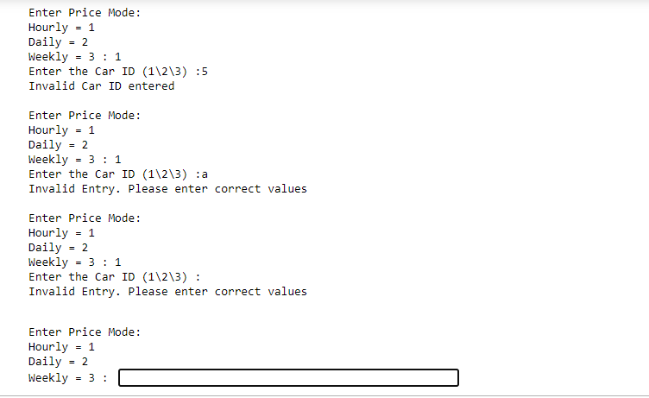

Test 4c
Enter more number of cars than available
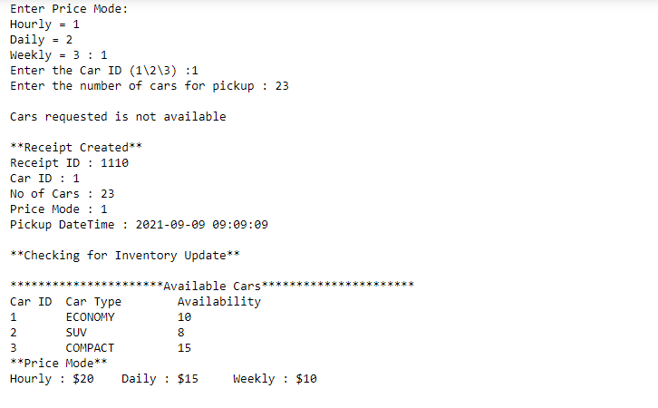
Test 5:
If the Car requested is available. Receipt id for pick up

Test 6:
Car inventory is updated accordingly – Display Car inventory
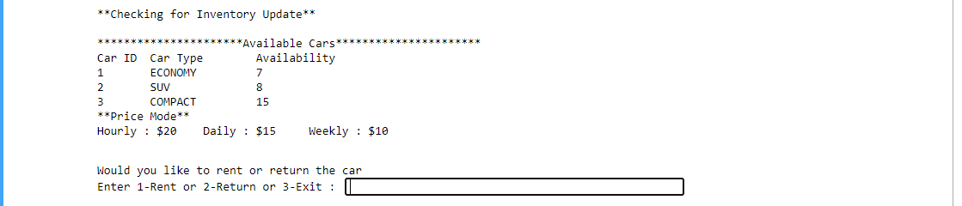

Test 7
Entered 2 to return Car
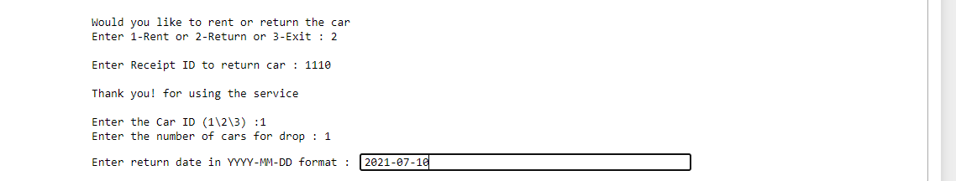
receipt Id updated

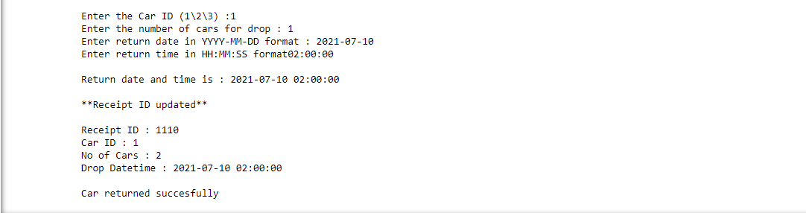

Bill generated and Car inventory updated accordingly
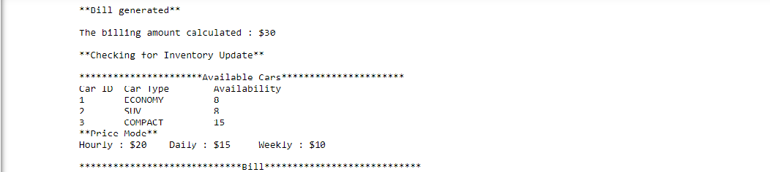

Bill Display
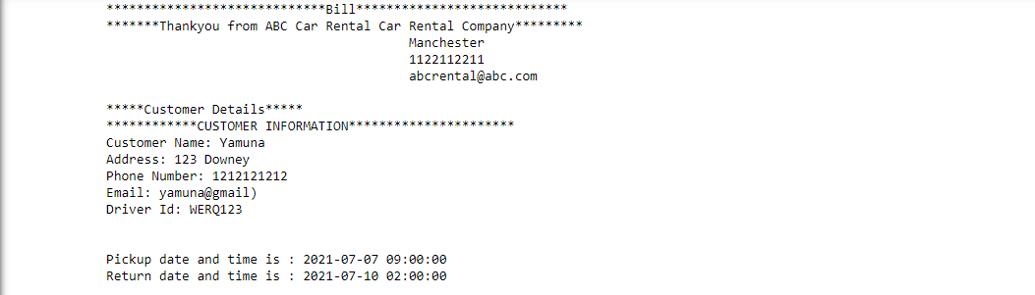
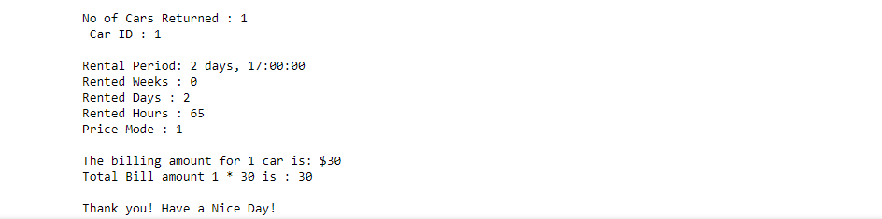

Test 7a
Enter Invalid Receipt id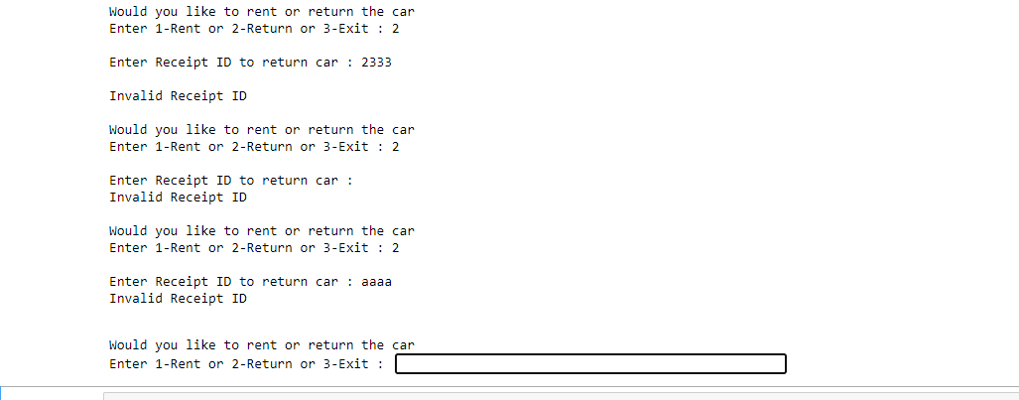

Test 7b
Enter invalid Car ID not rented and mapped to receipt id
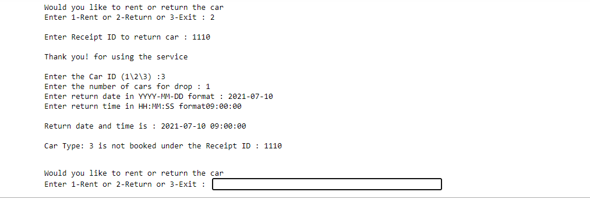

Test 7c:
Enter Invalid no of cars to return – entering more number of cars than booked
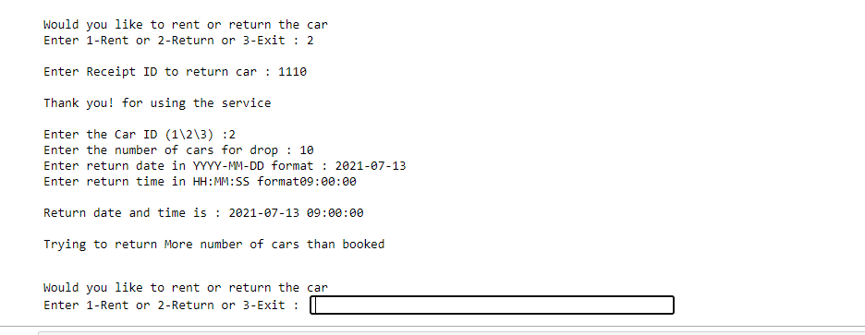

Screenshot to show Receipt id mapped to customer and Car pick up details.
Later used to check while returning and generate bill
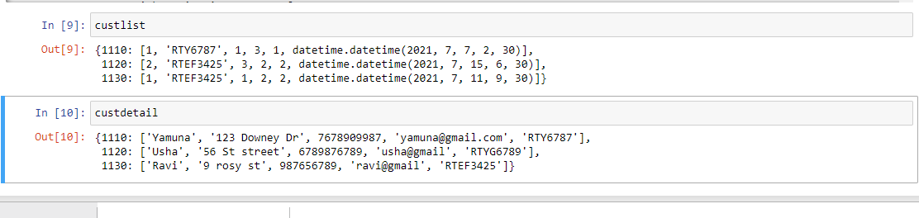

More screenshots to show Different Customer – Renting a car
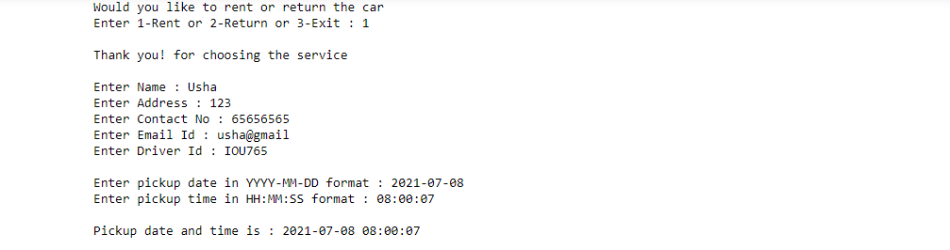
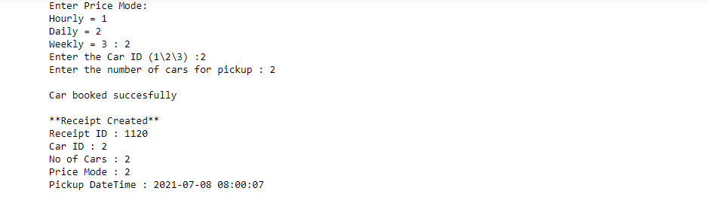
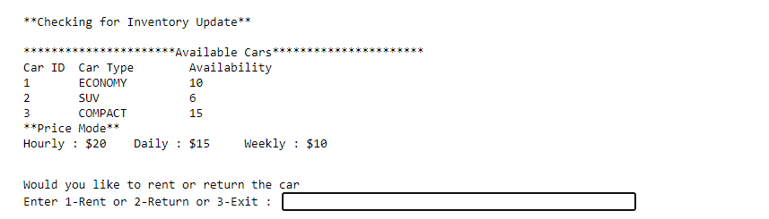

Final output
*******Welcome to ABC Car Rental Car Rental Company*********
Manchester
1122112211
abcrental@abc.com

**********************Available Cars**********************
Car ID Car Type Availability
1 ECONOMY 10
2 SUV 8
3 COMPACT 15
**Price Mode**
Hourly : $20 Daily : $15 Weekly : $10

Would you like to rent or return the car
Enter 1-Rent or 2-Return or 3-Exit : 1

Thank you! for choosing the service

Enter Name : Yamuna
Enter Address : 123 Downey Dr
Enter Contact No : 7678909987
Enter Email Id : yamuna@gmail.com
Enter Driver Id : RTY6787

Enter pickup date in YYYY-MM-DD format : 2021-07-07
Enter pickup time in HH:MM:SS format : 02:30:00

Pickup date and time is : 2021-07-07 02:30:00

Enter Price Mode:
Hourly = 1
Daily = 2
Weekly = 3 : 1
Enter the Car ID (1\2\3) :1
Enter the number of cars for pickup : 3

Car booked succesfully

**Receipt Created**
Receipt ID : 1110
Car ID : 1
No of Cars : 3
Price Mode : 1
Pickup DateTime : 2021-07-07 02:30:00

**Checking for Inventory Update**

**********************Available Cars**********************
Car ID Car Type Availability
1 ECONOMY 7
2 SUV 8
3 COMPACT 15
**Price Mode**
Hourly : $20 Daily : $15 Weekly : $10

Would you like to rent or return the car
Enter 1-Rent or 2-Return or 3-Exit : 1

Thank you! for choosing the service

Enter Name : Usha
Enter Address : 56 St street
Enter Contact No : 6789876789
Enter Email Id : usha@gmail
Enter Driver Id : RTYG6789

Enter pickup date in YYYY-MM-DD format : 2021-07-09
Enter pickup time in HH:MM:SS format : 09:00:00

Pickup date and time is : 2021-07-09 09:00:00

Enter Price Mode:
Hourly = 1
Daily = 2
Weekly = 3 : 3
Enter the Car ID (1\2\3) :3
Enter the number of cars for pickup : 4

Car booked succesfully

**Receipt Created**
Receipt ID : 1120
Car ID : 3
No of Cars : 4
Price Mode : 3
Pickup DateTime : 2021-07-09 09:00:00

**Checking for Inventory Update**

**********************Available Cars**********************
Car ID Car Type Availability
1 ECONOMY 7
2 SUV 8
3 COMPACT 11
**Price Mode**
Hourly : $20 Daily : $15 Weekly : $10

Would you like to rent or return the car
Enter 1-Rent or 2-Return or 3-Exit : 1

Thank you! for choosing the service

Enter Name : Ravi
Enter Address : 9 rosy st
Enter Contact No : 987656789
Enter Email Id : ravi@gmail
Enter Driver Id : RTEF3425

Enter pickup date in YYYY-MM-DD format : 2021-07-11
Enter pickup time in HH:MM:SS format : 09:30:00

Pickup date and time is : 2021-07-11 09:30:00

Enter Price Mode:
Hourly = 1
Daily = 2
Weekly = 3 : 2
Enter the Car ID (1\2\3) :1
Enter the number of cars for pickup : 2

Car booked succesfully

**Receipt Created**
Receipt ID : 1130
Car ID : 1
No of Cars : 2
Price Mode : 2
Pickup DateTime : 2021-07-11 09:30:00

**Checking for Inventory Update**

**********************Available Cars**********************
Car ID Car Type Availability
1 ECONOMY 5
2 SUV 8
3 COMPACT 11
**Price Mode**
Hourly : $20 Daily : $15 Weekly : $10

Would you like to rent or return the car
Enter 1-Rent or 2-Return or 3-Exit : 2

Enter Receipt ID to return car : 1120

Thank you! for using the service

Enter the Car ID (1\2\3) :3
Enter the number of cars for drop : 2
Enter return date in YYYY-MM-DD format : 2021-07-15
Enter return time in HH:MM:SS format06:30:00

Return date and time is : 2021-07-15 06:30:00

**Receipt ID updated**

Receipt ID : 1120
Car ID : 3
No of Cars : 2
Drop Datetime : 2021-07-15 06:30:00

Car returned succesfully

**Bill generated**

The billing amount calculated : $50

**Checking for Inventory Update**

**********************Available Cars**********************
Car ID Car Type Availability
1 ECONOMY 5
2 SUV 8
3 COMPACT 13
**Price Mode**
Hourly : $20 Daily : $15 Weekly : $10

*****************************Bill****************************
*******Thankyou from ABC Car Rental Car Rental Company*********
Manchester
1122112211
abcrental@abc.com

*****Customer Details*****
************CUSTOMER INFORMATION**********************
Customer Name: Usha
Address: 56 St street
Phone Number: 6789876789
Email: usha@gmail
Driver Id: RTYG6789

Pickup date and time is : 2021-07-09 09:00:00
Return date and time is : 2021-07-15 06:30:00

No of Cars Returned : 2
Car ID : 3

Rental Period: 5 days, 21:30:00
Rented Weeks : 0
Rented Days : 5
Rented Hours : 141
Price Mode : 3

The billing amount for 1 car is: $50
Total Bill amount 2 * 50 is : 100

Thank you! Have a Nice Day!

